Group Members:
- Ali Asghar (2059)
- Shahad Bangash (1980)
- Suleman Shah (1983)

Converted Relational Schema:
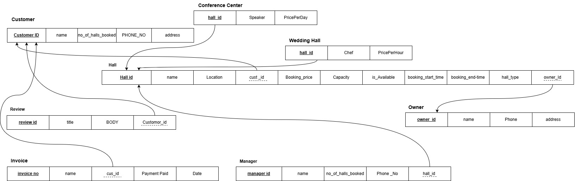
Figure 1-1, Converted Relational Schema of Hall Booking System

Normalized Relational Schema:
First Normal Form (1NF)
The current schema is in 1NF as all attributes contain no multivalued attributes.

Second Normal Form (2NF)
All tables satisfy 2NF as there is no partial dependencies.

Third Normal Form (3NF)
All tables satisfy 3NF as there is no transitive dependencies.

Normalized Relational Schema:
We have designed our database of Hall Booking System. Starting from our conceptual schema to relational schema, in the process we did not find any partial, or transitive dependencies in our relational schema. Our final relational Schema is shown in figure 1-2, which is same as figure 1-1.

Figure 1-2, Normalized Relational Schema of Hall Booking System

